Asian Conference on Institutional and Action Research 2018
December 3-5, 2018
The Selah Pods, Pasay City, Manila, Philippines

OBSERVER REGISTRATION FORM

Theme: “Using Scientific Evidence in Everyday Worklife for Optimum Outcomes”
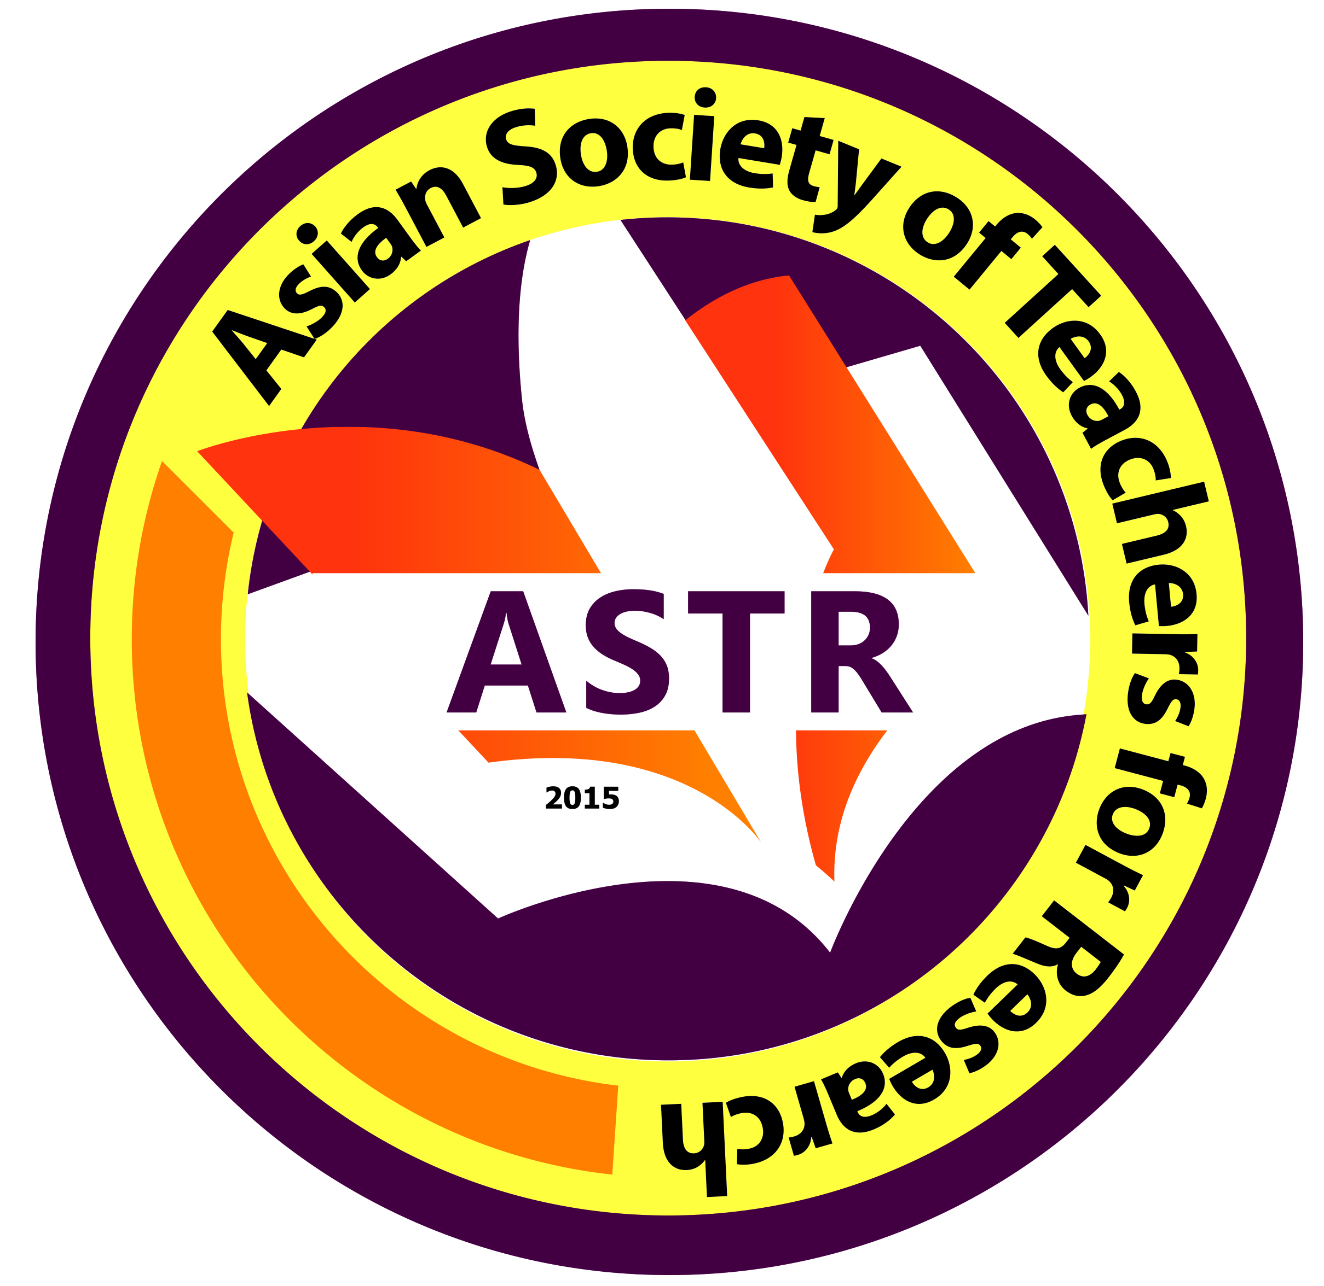
Date Filed:

First Name:
Middle Name:
Last Name:
Email Address:
Mobile No. (begin with country code):
ORCID No (register at www.orcid.org):
Field(s) of Expertise:
Organization/School/University/Affiliation:
Address of Organization/School/University/Affiliation:

*Please attached the following documents together with this filled-out form:
(a) formal ID Photo;
(b) Updated Curriculum Vitae;
(c) deposit slip

